20.2 Medicaid Eligibility Quality Control (MEQC) Online Functionality

The online functional group of the Medicaid Eligibility Quality Control Subsystem is:

- MEQC Parameters Functional Group

20.2.1 MEQC Parameters Functional Group

This functional group allows the user to specify criteria for the sampling clients and their claims information for the production of reports from claims history.

The following GOTO table presents the GOTO navigation capabilities for the functional group. For each GOTO option in the functional group, the following is identified: the subsystem and functional group navigated to when the GOTO option is selected, the window field used as the key field for the GOTO functional group, and the window name where the key field resides (if appropriate).

GOTO Subsystem | GOTO Functional Group | Window Field | Window
Control Panel | None | None | All

The following tab page is used by the MEQC Parameter functional group:

- MEQC Parameters

NEW MEXICO OMNICAID MMIS CLAIMS SUBSYSTEM
WINDOW SPECIFICATION
MEQC PARAMETERS FUNCTIONAL GROUP
MEQC PARAMETERS WINDOW

Window Object Name: W_CLAIM_MEQC_PARAM
Description:
This window provides a method for the user to enter the MEQC parameters that control the MEQC selection process. The MEQC Process Date entered must be equal to or greater than the system date, and will be the actual date for the next MEQC run. The Primary Selection Month and Year entered must be at least six months and no more than twelve months prior to the Process Date. Months to be sampled may not be greater than the difference between the Process Date and the Begin Date plus one month. Months for paid claims and months for adjustment should be at least one month greater than the number of months sampled, but the range must not extend past the Process Date.

The universe of eligible cases will be counted, and when equal to the Offset, the first case is selected. Cases are selected thereafter by the Interval.

Special Security Requirements:
Authorized personnel to control report processes.

Presentation Sequence(s):
N/A

Remarks:
N/A

NEW MEXICO OMNICAID MMIS CLAIMS SUBSYSTEM
WINDOW LAYOUT
MEQC PARAMETERS FUNCTIONAL GROUP
MEQC PARAMETERS WINDOW

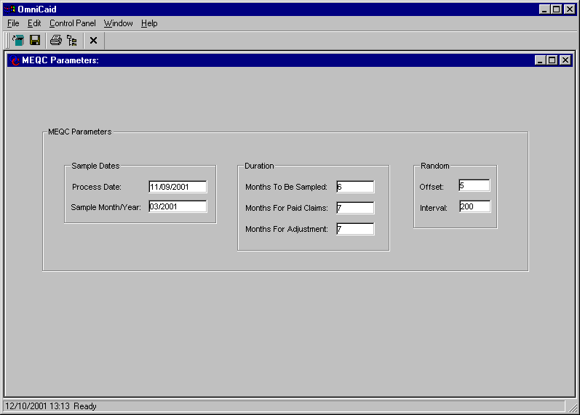
NEW MEXICO OMNICAID MMIS CLAIMS SUBSYSTEM
WINDOW EXHIBIT
MEQC PARAMETERS FUNCTIONAL GROUP
MEQC PARAMETERS WINDOW

Field Name | Table  Column Name | Table Name | Format | Prot (A,C,N) | Req  (A,C,N) | Std Edits | Specifications | Note  Ref
Process Date | Q_MEQC_PROC_DT | Q_MEQC_PARAM_TB | DATE (MMDDCCYY) | C | A | D | DATE > OR = SYSTEM MONTH/YEAR. The MEQC process run when the system date equals the Process Date.
Sample Month/Year | Q_MEQC_BEG_SAMP_YM | Q_MEQC_PARAM_TB | Date (MMCCYY) | C | A | N/A | The Month/Year entered must be six to twelve months prior to the System Month/Year.
Months To Be Sampled | Q_MEQC_MO_SAMP_NUM | Q_MEQC_PARAM_TB | Small int | C | A | N | The number of months to be sampled. The number must not be greater than the difference between the Process Date and begin month + 1.
Months For  Paid Claims | Q_MEQC_ADJUD_NUM | Q_MEQC_PARAM_TB | Small int | C | A | N | The number of months that define the range of dates to select paid claims information.
Months For  Adjustment | Q_MEQC_ADJ_NUM | Q_MEQC_PARAM_TB | Small int | C | A | N | The number of months that define the range of dates to select Adjustment information.
Offset | Q_MEQC_OFFSET_NUM | Q_MEQC_PARAM_TB | Small int | C | N | N | The number of valid cases bypassed before the first case is selected for MEQC sampling.  Maximum value of 32,767.
Interval | Q_MEQC_INTV_NUM | Q_MEQC_PARAM_TB | Small int | C | N | N | The number of valid cases bypassed between valid sample cases for MEQC samples. Maximum value of 32,767.

_________________________________________________________________________________________________________________________________

LEGEND: For Prot and Req: A = Always For Std Edits: D = Date Edit V = Valid Value Edit
C = Conditionally N = Numeric Edits S = System Generated
N = Never

